PRESS RELEASE, Huddinge Sweden 15-Oct-2024

**Improving Access to Target Cells for Cell and Gene Therapy**

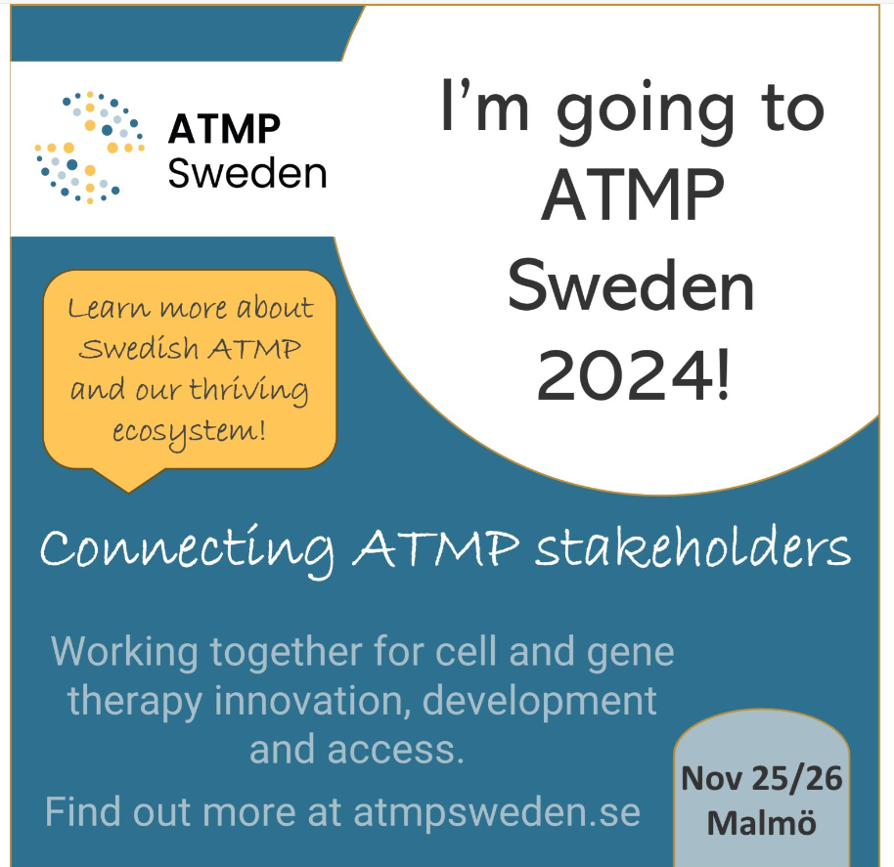

Of course, we´re going! Wouldn't miss it for the world. We have a special event in Sweden which trying to bring in all Swedish ATMP stakeholders. It makes for an interesting network, where the stakeholders are better informed about the other competencies required in the space.

We believe this event will help to build effective collaborations.

Will we see you in November?

Come and meet us to discuss our services in Cell and Gene therapy,

we have booth number 25.

See you there!

[ATMP Sweden – A network för Advanced Therapy Medicinal Products](https://atmpsweden.se/)

**About OptiCell Solutions**

Founded in 2024, OptiCell Solutions AB specializing in the field of apheresis and cell collection for gene and cell therapies (CAGT). By using our advanced apheresis technology, we can collect large quantities of specific donor cells, significantly advancing CAGT applications within in the biotech and healthcare sector.

Furthermore, our extensive experience and know-how in apheresis enable us to offer specialized therapeutic apheresis service to the healthcare sector. We are providing the industry and healthcare sector with services in setting up and coordinating clinical trials in the CAGT field.

Located near the Karolinska University Hospital in Huddinge we aim to bridge the gap in resources by offering innovative solutions that enhance the availability of essential cells for groundbreaking research and life-saving therapies.

With our deep expertise in apheresis technology and a strong commitment to ethical research practices, we are dedicated to improving patient outcomes and supporting the development of next-generation therapies for cancer, autoimmune diseases, and other severe medical conditions.

At OptiCell Solutions, we strive to be at the forefront of medical innovation, providing the tools and services necessary to accelerate the transition to more effective and patient-centred care.

--- END PRESS RELEASE ---